Data structures are fundamental to any programming language. The choice of a particular data structure has a significant impact on the functionality and performance of Java applications, thus it is worthwhile to master data structures in Java.

This guide will help beginners to understand what is data structures, what is data structures in Java, the types of data structures in Java and many more.

* **What is Java?**
* **What are Data Structures?**
* **What are Data Structures in Java?**
* **Types of Data Structures in Java**
* **Advantages of Data Structures in java**
* **Classification of Data Structures**

**What is Java?**

Java Programming is a high-level programming language created by sun microsystems. This programming language is reliable, object-oriented and secure. Java follows the WORA principle, which stands for “Write Once Run Anywhere”. You can run a java program as many times as you want on a java supported platform after it is compiled.

**What are Data Structures?**

A data structure is defined as a format for arranging, processing, accessing, and storing data. Data structures are the combination of both simple and complex forms, all of which are made to organise data for a certain use. Users find it simple to access the data they need and use it appropriately thanks to data structures.

## ****What are Data Structures in Java?****

Data Structure in java is defined as the collection of data pieces that offers an effective means of storing and organising data in a computer. Linked List, Stack, Queue, and arrays are a few examples of java data structures.

## ****Types of Data Structures in Java****

Here is the list of some of the common types of data structures in Java:

* Array
* Linked List
* Stack
* Queue
* Binary Tree
* Binary Search Tree
* Hashing
* Graph

**Here is the pictorial representation of types of java data structures**

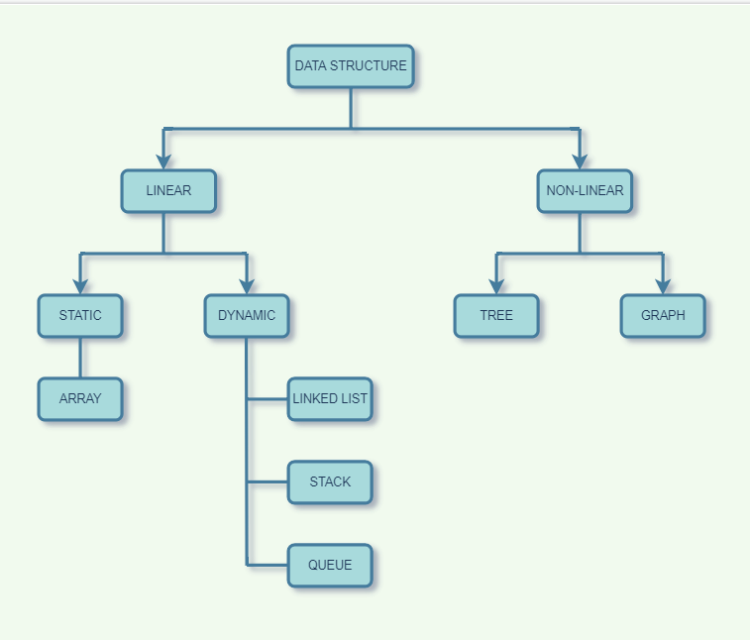

### ****Further classification of types of Data Structures****

There are two types of Data Structures:-

1. Primitive Data Structures
2. Non-primitive Data Structures

**Primitive data Structures**are also called Primitive Data Types. byte, short,  int, float, char, boolean, long, and double are primitive Data types.

**Non-primitive data Structures** – Non-primitive Data Structures are of two types:-

1. Linear Data Structures
2. Non-linear Data Structures

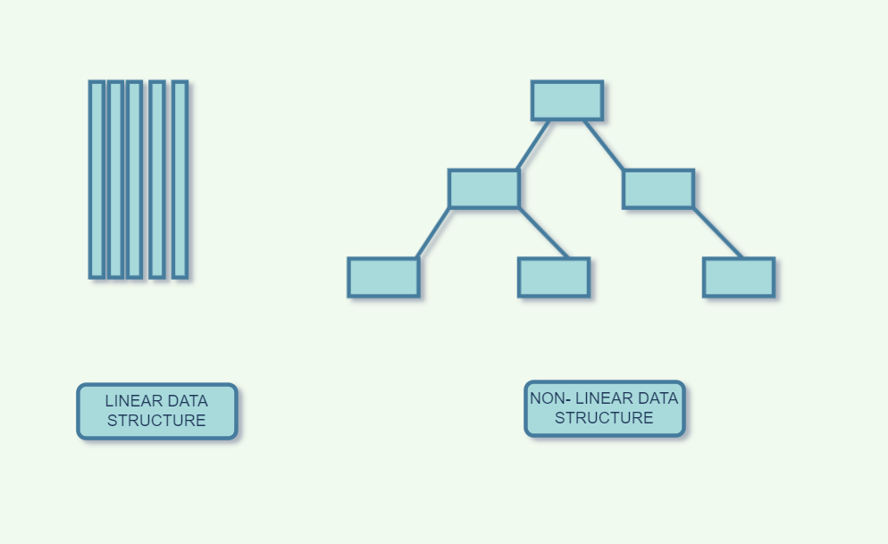

**Linear Data Structures** – The elements arranged in a linear fashion are called Linear Data Structures. Here, each element is connected to one other element only. Linear Data Structures are as follows:

* **Arrays**
  + Single dimensional Array
  + Multidimensional Array
* **Stack**
* **Queue**
* **Linked List**
  + Singly-linked list
  + Doubly Linked list
  + Circular Linked List

**Non-Linear Data Structures** – The elements arranged in a non-linear fashion are called Non-Linear Data Structures. Here, each element is connected to n-other elements. Non-Linear Data Structures are as follows:

* **Trees**
  + Binary Tree
  + Binary Search Tree
  + AVL Tree
  + Red-Black Tree
* **Graph**
* **Hash**
  + HashSet
  + HashMap

## ****Advantages of Data Structures in java****

* Efficiency
* Reusability
* Processing Speed
* Abstraction
* Data Searching

## ****Classification of Data Structures****

**Data Structures can be classified as:-**

* **Static Data Structures** are the Data structures whose size is declared and fixed at Compile Time and cannot be changed later are called Static Data structures.
* **Example – Arrays**
* **Dynamic Data Structures** are the Data Structures whose size is not fixed at compile time and can be decided at runtime depending upon requirements are called Dynamic Data structures.
* **Example – Binary Search Tree**
* **Syntax:**

|  |  |
| --- | --- |
| 1  2  3 | Array declaration  datatype varname []=new datatype[size];  datatype[] varname=new datatype[size]; |

## ****Array****

### ****What is an Array?****

An array is the simplest data structure where a collection of similar data elements takes place and each data element can be accessed directly by only using its index number.

#### ****Array Advantages****

* Random access
* Easy sorting and iteration
* Replacement of multiple variables

#### ****Array Disadvantages****

* Size is fixed
* Difficult to insert and delete
* If capacity is more and occupancy less, most of the array gets wasted
* Needs contiguous memory to get allocated

#### ****Array Applications****

* For storing information in a linear fashion
* Suitable for applications that require frequent searching

## ****Java Program using Array****

import java.util.*;

class JavaDemo {

public static void main (String[] args) {

int[] priceOfPen= new int[5];

Scanner in=new Scanner(System.in);

for(int i=0;i<priceOfPen.length;i++)

priceOfPen[i]=in.nextInt();

for(int i=0;i<priceOfPen.length;i++)

System.out.print(priceOfPen[i]+" ");

}

}

Input:

23 13 56 78 10

Output:

23 13 56 78 10

## ****Linked List****

### ****What is Linked List?****

Linked list data structure helps the required objects to be arranged in a linear order.

#### ****Linked List Advantages****

* Dynamic in size
* No wastage as capacity and size is always equal
* Easy insertion and deletion as 1 link manipulation is required
* Efficient memory allocation

#### ****Linked List**** ****Disadvantages****

* If head Node is lost, the linked list is lost
* No random access is possible

#### ****Linked List**** ****Applications****

* Suitable where memory is limited
* Suitable for applications that require frequent insertion and deletion

## ****Java Program on Linked List****

import java.util.*;

class LLNode{

int data;

LLNode next;

LLNode(int data)

{

this.data=data;

this.next=null;

}

}

class Demo{

LLNode head;

LLNode insertInBeg(int key,LLNode head)

{

LLNode ttmp=new LLNode(key);

if(head==null)

head=ttmp;

else

{

ttmp.next=head;

head=ttmp;

}

return head;

}

LLNode insertInEnd(int key,LLNode head)

{

LLNode ttmp=new LLNode(key);

LLNode ttmp1=head;

if(ttmp1==null)

head=ttmp;

else

{

while(ttmp1.next!=null)

ttmp1=ttmp1.next;

ttmp1.next=ttmp;

}

return head;

}

LLNode insertAtPos(int key,int pos,LLNode head)

{

LLNode ttmp=new LLNode(key);

if(pos==1)

{

ttmp.next=head;

head=ttmp;

}

else

{

LLNode ttmp1=head;

for(int i=1;ttmp1!=null && i<pos;i++)

ttmp1=ttmp1.next;

ttmp.next=ttmp1.next;

ttmp1.next=ttmp;

}

return head;

}

LLNode delete(int pos,LLNode head)

{

LLNode ttmp=head;

if(pos==1)

head=ttmp.next;

else

{

for(int i=1;ttmp!=null && i<pos-1;i++)

ttmp=ttmp.next;

ttmp.next=ttmp.next.next;

}

return head;

}

int length(LLNode head)

{

LLNode ttmp=head;

int c=0;

if(ttmp==null)

return 0;

else

{

while(ttmp!=null)

{ ttmp=ttmp.next;

c++;

}

}

return c;

}

LLNode reverse(LLNode head)

{

LLNode prevLNode=null,curLNode=head,nextLNode=null;

while(curLNode!=null)

{

nextLNode=curLNode.next;

curLNode.next=prevLNode;

prevLNode=curLNode;

curLNode=nextLNode;

}

head=prevLNode;

return head;

}

void display(LLNode head)

{

LLNode ttmp=head;

while(ttmp!=null)

{System.out.print(ttmp.data+" ");

ttmp=ttmp.next;

}

}

public static void main(String[] args)

{

LinkedListDemo l=new LinkedListDemo();

l.head=null;

Scanner in=new Scanner(System.in);

do

{

System.out.println("\n********* MENU *********");

System.out.println("\n1.Insert In End");

System.out.println("\n2.Insert In Beg");

System.out.println("\n3.Insert At A Particular Pos");

System.out.println("\n4.Delete At a Pos");

System.out.println("\n5.Length");

System.out.println("\n6.Reverse");

System.out.println("\n7.Display");

System.out.println("\n8.EXIT");

System.out.println("\nenter ur choice : ");

int n=in.nextInt();

switch(n)

{case 1: System.out.println("\nenter the value ");

l.head=l.insertInEnd(in.nextInt(),l.head);

break;

case 2: System.out.println("\nenter the value");

l.head=l.insertInBeg(in.nextInt(),l.head);

break;

case 3: System.out.println("\nenter the value");

l.head=l.insertAtPos(in.nextInt(),in.nextInt(),l.head);

break;

case 4:

l.head=l.delete(in.nextInt(),l.head);

break;

case 5:

System.out.println(l.length(l.head));

break;

case 6:

l.head=l.reverse(l.head);

break;

case 7:

l.display(l.head);

break;

case 8: System.exit(0);

break;

default: System.out.println("\n Wrong Choice!");

break;

}

System.out.println("\n do u want to cont... ");

}while(in.nextInt()==1);

}

}

Output:

********* MENU *********

1.Insert In End

2.Insert In Beg

3.Insert At A Particular Pos

4.Delete At a Pos

5.Length

6.Reverse

7.Display

8.EXIT

enter ur choice :

1

enter the value

23

do u want to cont...

1

********* MENU *********

1.Insert In End

2.Insert In Beg

3.Insert At A Particular Pos

4.Delete At a Pos

5.Length

6.Reverse

7.Display

8.EXIT

enter ur choice :

1

enter the value

56

do u want to cont...

1

********* MENU *********

1.Insert In End

2.Insert In Beg

3.Insert At A Particular Pos

4.Delete At a Pos

5.Length

6.Reverse

7.Display

8.EXIT

enter ur choice :

2

enter the value

10

do u want to cont...

1

********* MENU *********

1.Insert In End

2.Insert In Beg

3.Insert At A Particular Pos

4.Delete At a Pos

5.Length

6.Reverse

7.Display

8.EXIT

enter ur choice :

7

10 23 56

do u want to cont...

1

********* MENU *********

1.Insert In End

2.Insert In Beg

3.Insert At A Particular Pos

4.Delete At a Pos

5.Length

6.Reverse

7.Display

8.EXIT

enter ur choice :

3

enter the value

67

2

do u want to cont...

1

********* MENU *********

1.Insert In End

2.Insert In Beg

3.Insert At A Particular Pos

4.Delete At a Pos

5.Length

6.Reverse

7.Display

8.EXIT

enter ur choice :

7

10 23 67 56

do u want to cont...

1

********* MENU *********

1.Insert In End

2.Insert In Beg

3.Insert At A Particular Pos

4.Delete At a Pos

5.Length

6.Reverse

7.Display

8.EXIT

enter ur choice :

4

2

do u want to cont...

1

********* MENU *********

1.Insert In End

2.Insert In Beg

3.Insert At A Particular Pos

4.Delete At a Pos

5.Length

6.Reverse

7.Display

8.EXIT

enter ur choice :

7

10 67 56

do u want to cont...

1

********* MENU *********

1.Insert In End

2.Insert In Beg

3.Insert At A Particular Pos

4.Delete At a Pos

5.Length

6.Reverse

7.Display

8.EXIT

enter ur choice :

6

do u want to cont...

1

********* MENU *********

1.Insert In End

2.Insert In Beg

3.Insert At A Particular Pos

4.Delete At a Pos

5.Length

6.Reverse

7.Display

8.EXIT

enter ur choice :

7

56 67 10

do u want to cont...

## ****Stack****

### ****What is a stack?****

A stack is a representation of nodes. There are two components to each node: data and next (storing address of next node). Each node’s data portion contains the assigned value, and its next pointer directs the user to the node that has the stack’s subsequent item. The highest node in the stack is referred to as the top.

#### ****Features of Stack****

* Linear Data Structures using Java
* Follows LIFO: Last In First Out
* Only the top elements are available to be accessed
* Insertion and deletion takes place from the top
* Eg: a stack of plates, chairs, etc
* 4 major operations:
  + push(ele) – used to insert element at top
  + pop() – removes the top element from stack
  + isEmpty() – returns true is stack is empty
  + peek() – to get the top element of the stack
* All operation works in constant time i.e, O(1)

#### ****Stack Advantages****

* Maintains data in a LIFO manner
* The last element is readily available for use
* All operations are of O(1) complexity

#### ****Stack Disadvantages****

* Manipulation is restricted to the top of the stack
* Not much flexible

#### ****Stack Applications****

* Recursion
* Parsing
* Browser
* Editors

## ****Java Program using Stack****

import java.util.*;

class Stack

{

int[] a;

int top;

Stack()

{

a=new int[100];

top=-1;

}

void push(int x)

{

if(top==a.length-1)

System.out.println("overflow");

else

a[++top]=x;

}

int pop()

{

if(top==-1)

{System.out.println("underflow");

return -1;

}

else

return(a[top--]);

}

void display()

{

for(int i=0;i<=top;i++)

System.out.print(a[i]+" ");

System.out.println();

}

boolean isEmpty()

{

if(top==-1)

return true;

else

return false;

}

int peek()

{

if(top==-1)

return -1;

return (a[top]);

}

}

public class Demo

{

public static void main(String args[])

{

Stack s=new Stack();

Scanner in= new Scanner(System.in);

do

{System.out.println("\n******** MENU *******");

System.out.println("\n1.PUSH");

System.out.println("\n2.POP");

System.out.println("\n3.PEEK");

System.out.println("\n4 IS EMPTY");

System.out.println("\n5.EXIT");

System.out.println("\n enter ur choice : ");

switch(in.nextInt())

{

case 1:

System.out.println("\nenter the value ");

s.push(in.nextInt());

break;

case 2:

System.out.println("\n popped element : "+ s.pop());

break;

case 3:

System.out.println("\n top element : "+ s.peek());

break;

case 4: System.out.println("\n is empty : "+ s.isEmpty());

break;

case 5: System.exit(0);

break;

default: System.out.println("\n Wrong Choice!");

break;

}

System.out.println("\n do u want to cont... ");

}while(in.nextInt()==1);

}

}

Output:

******** MENU *******

1.PUSH

2.POP

3.PEEK

4 IS EMPTY

5.EXIT

enter ur choice :

1

enter the value

12

do u want to cont...

1

******** MENU *******

1.PUSH

2.POP

3.PEEK

4 IS EMPTY

5.EXIT

enter ur choice :

1

enter the value

56

do u want to cont...

1

******** MENU *******

1.PUSH

2.POP

3.PEEK

4 IS EMPTY

5.EXIT

enter ur choice :

2

popped element : 56

do u want to cont...

1

******** MENU *******

1.PUSH

2.POP

3.PEEK

4 IS EMPTY

5.EXIT

enter ur choice :

4

is empty : false

do u want to cont...

1

******** MENU *******

1.PUSH

2.POP

3.PEEK

4 IS EMPTY

5.EXIT

enter ur choice :

2

popped element : 12

## ****Java Data structure program of Stack – using LinkedList****

import java.util.*;

class LNode

{

int data;

LNode next;

LNode(int d)

{

data=d;

}

}

class Stack

{

LNode push(int d,LNode head){

LNode tmp1 = new LNode(d);

if(head==null)

head=tmp1;

else

{

tmp1.next=head;

head=tmp1;

}

return head;

}

LNode pop(LNode head){

if(head==null)

System.out.println("underflow");

else

head=head.next;

return head;

}

void display(LNode head){

System.out.println("\n list is : ");

if(head==null){

System.out.println("no LNodes");

return;

}

LNode tmp=head;

while(tmp!=null){

System.out.print(tmp.data+" ");

tmp=tmp.next;

}

}

boolean isEmpty(LNode head)

{

if(head==null)

return true;

else

return false;

}

int peek(LNode head)

{

if(head==null)

return -1;

return head.data;

}

}

public class Demo{

public static void main(String[] args)

{

Stack s=new Stack();

LNode head=null;

Scanner in=new Scanner(System.in);

do

{System.out.println("\n******** MENU *******");

System.out.println("\n1.PUSH");

System.out.println("\n2.POP");

System.out.println("\n3.PEEK");

System.out.println("\n4 IS EMPTY");

System.out.println("\n5 DISPLAY");

System.out.println("\n6.EXIT");

System.out.println("\n enter ur choice : ");

switch(in.nextInt())

{

case 1:

System.out.println("\nenter the value ");

head=s.push(in.nextInt(),head);

break;

case 2:

head=s.pop(head);

break;

case 3:

System.out.println("\n top element : "+ s.peek(head));

break;

case 4:

System.out.println("\n is empty : "+ s.isEmpty(head));

break;

case 5: s.display(head);

break;

case 6: System.exit(0);

break;

default: System.out.println("\n Wrong Choice!");

break;

}

System.out.println("\n do u want to cont... ");

}while(in.nextInt()==1);

}

}

Output

******** MENU *******

1.PUSH

2.POP

3.PEEK

4 IS EMPTY

5 DISPLAY

6.EXIT

enter ur choice :

1

enter the value

12

do u want to cont...

1

******** MENU *******

1.PUSH

2.POP

3.PEEK

4 IS EMPTY

5 DISPLAY

6.EXIT

enter ur choice :

1

enter the value

56

do u want to cont...

1

******** MENU *******

1.PUSH

2.POP

3.PEEK

4 IS EMPTY

5 DISPLAY

6.EXIT

enter ur choice :

5

list is :

56 12

do u want to cont...

1

******** MENU *******

1.PUSH

2.POP

3.PEEK

4 IS EMPTY

5 DISPLAY

6.EXIT

enter ur choice :

3

top element : 56

do u want to cont...

1

******** MENU *******

1.PUSH

2.POP

3.PEEK

4 IS EMPTY

5 DISPLAY

6.EXIT

enter ur choice :

4

is empty : false

do u want to cont...

1

## ****Queue****

### ****What is Queue?****

The queue is called an abstract data structure. Data is always added to one end (enqueued), and removed from the other (dequeue). Queue uses the First-In-First-Out approach and data item that was stored initially will be accessed first in a queue.

#### ****Features of Queue****

* Linear Data Structure
* Follows FIFO: First In First Out
* Insertion can take place from the rear end.
* Deletion can take place from the front end.
* Eg: queue at ticket counters, bus station
* 4 major operations:
  + enqueue(ele) – used to insert element at top
  + dequeue() – removes the top element from queue
  + peekfirst() – to get the first element of the queue
  + peeklast() – to get the last element of the queue
* All operation works in constant time i.e, O(1)

#### ****Queue Advantages****

* Maintains data in FIFO manner
* Insertion from beginning and deletion from end takes O(1) time

#### ****Queue Applications****

* Scheduling
* Maintaining playlist
* Interrupt handling

**Variations in Queue:** Two popular variations of queues are **Circular queues** and **Dequeues.**

## ****Java program of Queue- using Array****

import java.util.*;

class Queue{

int front;

int rear;

int[] arr;

Queue()

{

front=rear=-1;

arr=new int[10];

}

void enqueue(int a)

{

if(rear==arr.length-1)

System.out.println("overflow");

else

arr[++rear]=a;

if(front==-1)

front++;

}

int dequeue()

{

int x=-1;

if(front==-1)

System.out.println("underflow");

else

x=arr[front++];

if(rear==0)

rear--;

return x;

}

void display()

{

for(int i=front;i<=rear;i++)

System.out.print(arr[i]+" ");

System.out.println();

}

}

public class QueueDemo{

public static void main(String[] args)

{

Queue ob=new Queue();

ob.enqueue(1);

ob.enqueue(2);

ob.enqueue(3);

ob.enqueue(4);

ob.enqueue(5);

ob.display();

ob.dequeue();

ob.display();

}

}

Output:

1 2 3 4 5

2 3 4 5

## ****Demonstration of Queue- using LinkedList****

class LNode{

int data;

LNode next;

LNode(int d)

{

data=d;

}

}

class Queue{

LNode enqueue(LNode head,int a)

{

LNode tmp=new LNode(a);

if(head==null)

head=tmp;

else

{

LNode tmp1=head;

while(tmp1.next!=null)

tmp1=tmp1.next;

tmp1.next=tmp;

}

return head;

}

LNode dequeue(LNode head)

{

if(head==null)

System.out.println("underflow");

else

head=head.next;

return head;

}

void display(LNode head)

{

System.out.println("\n list is : ");

if(head==null){

System.out.println("no LNodes");

return;

}

LNode tmp=head;

while(tmp!=null){

System.out.print(tmp.data+" ");

tmp=tmp.next;

}

}

}

public class QueueDemoLL{

public static void main(String[] args)

{

Queue ob=new Queue();

LNode head=null;

head=ob.enqueue(head,1);

head=ob.enqueue(head,2);

head=ob.enqueue(head,3);

head=ob.enqueue(head,4);

head=ob.enqueue(head,5);

ob.display(head);

head=ob.dequeue(head);

ob.display(head);

}

}

Output

list is :

1 2 3 4 5

list is :

2 3 4 5

## ****Binary Tree****

### ****What is a Binary Tree?****

In a binary tree, the branches of the tree are made up of up to two child nodes for each node. The left and right nodes are the common names for the two youngsters. Child nodes make references to their parents, whereas parent nodes are nodes with children.

**Features of Binary Tree**

* Hierarchical  Data Structure
* The topmost element is known as the root of the tree
* Every Node can have at most 2 children in the binary tree
* Can access elements randomly using index
* Eg: File system hierarchy
* Common traversal methods:
  + preorder(root) : print-left-right
  + postorder(root) : left-right-print
  + inorder(root) : left-print-right

#### ****Binary Tree Advantages****

* Can represent data with some relationship
* Insertion and search are much more efficient

#### ****Binary Tree Disadvantages****

* Sorting is difficult
* Not much flexible

#### ****Binary Tree Applications****

* File system hierarchy
* Multiple variations of the binary tree have a wide variety of applications

## ****Demonstration of Binary Tree****

class TLNode

{

int data;

TLNode left,right;

TLNode(int d)

{

data=d;

}

}

public class BinaryTree

{

static void preorder(TLNode r)

{

if(r==null)

return;

System.out.print(r.data+" ");

preorder(r.left);

preorder(r.right);

}

static void inorder(TLNode r)

{

if(r==null)

return;

inorder(r.left);

System.out.print(r.data+" ");

inorder(r.right);

}

static void postorder(TLNode r)

{

if(r==null)

return;

postorder(r.left);

postorder(r.right);

System.out.print(r.data+" ");

}

public static void main(String[] args)

{

TLNode root=new TLNode(1);

root.left=new TLNode(2);

root.right=new TLNode(3);

root.left.left=new TLNode(4);

root.left.right=new TLNode(5);

root.right.left=new TLNode(6);

root.right.right=new TLNode(7);

preorder(root);

System.out.println();

inorder(root);

System.out.println();

postorder(root);

System.out.println();

}

}

Output

1 2 4 5 3 6 7

4 2 5 1 6 3 7

4 5 2 6 7 3 1

## ****Binary Search Tree****

### ****What is a Binary Search Tree?****

The binary search tree is an advanced algorithm which is used to analyse the nodes, branches and many more. The BST was developed using the architecture of a fundamental binary search algorithm, allowing for quicker node lookups, insertions, and removals.

**Features of Binary Search Tree**

* A binary tree with the additional restriction
* Restriction:
  + The left child must always be less than the root node
  + The right child must always be greater than the root node
* Insertion, Deletion, Search is much more efficient than a binary tree

#### ****Binary Search Tree**** ****Advantages****

* Maintains order in elements
* Can easily find the min and max Nodes in the tree
* In order, traversal gives sorted elements

#### ****Binary Search Tree**** ****Disadvantages****

* Random access is not possible
* Ordering adds complexity

#### ****Binary Search Tree**** ****Applications****

* Suitable for sorted hierarchical data

## ****Demonstration of Binary Search Tree****

class TLNode{

int data;

TLNode left,right;

TLNode(int d)

{

data=d;

}

}

public class BST{

TLNode root;

TLNode insert(int d,TLNode root)

{

if(root==null)

root=new TLNode(d);

else if(d<=root.data)

root.left=insert(d,root.left);

else

root.right=insert(d,root.right);

return root;

}

TLNode search(int d,TLNode root)

{

if(root.data==d)

return root;

else if(d<root.data)

return search(d,root.left);

else

return search(d,root.right);

}

void inorder(TLNode r)

{

if(r==null)

return;

inorder(r.left);

System.out.println(r.data);

inorder(r.right);

}

TLNode delete(TLNode root, int data)

{

if (root == null) return root;

if (data < root.data)

root.left = delete(root.left, data);

else if (data > root.data)

root.right = delete(root.right, data);

else

{

if (root.left == null)

return root.right;

else if (root.right == null)

return root.left;

root.data = minValue(root.right);

root.right = delete(root.right, root.data);

}

return root;

}

int minValue(TLNode root)

{

int minv = root.data;

while (root.left != null)

{

minv = root.left.data;

root = root.left;

}

return minv;

}

public static void main(String[] args)

{

BST ob=new BST();

ob.root=ob.insert(50,ob.root);

ob.root=ob.insert(30,ob.root);

ob.root=ob.insert(20,ob.root);

ob.root=ob.insert(20,ob.root);

ob.root=ob.insert(70,ob.root);

ob.root=ob.insert(60,ob.root);

ob.root=ob.insert(80,ob.root);

ob.root=ob.delete(ob.root,50);

System.out.println("******" +ob.root.data);

ob.inorder(ob.root);

TLNode find=ob.search(30,ob.root);

if(find==null)

System.out.println("not found");

else

System.out.println("found : "+find.data);

}

}

Output:

******60

20

20

30

60

70

80

found : 30

## ****Hashing****

* Uses special Hash function
* A hash function maps an element to an address for storage
* This provides constant-time access
* Collision resolution techniques handle collision
* Collision resolution technique
  + Chaining
  + Open Addressing

#### ****Hashing**** ****Advantages****

* The hash function helps in fetching elements in constant time
* An efficient way to store elements

#### ****Hashing**** ****Disadvantages****

* Collision resolution increases complexity

#### ****Hashing**** ****Applications****

* Suitable for the application needs constant time fetching

## ****Demonstration of HashSet – to find string has unique characters****

import java.util.*;

class HashSetDemo1{

static boolean isUnique(String s)

{

HashSet<Character> set =new HashSet<Character>();

for(int i=0;i<s.length();i++)

{

char c=s.charAt(i);

if(c==' ')

continue;

if(set.add(c)==false)

return false;

}

return true;

}

public static void main(String[] args)

{

String s="helo wqty ";

boolean ans=isUnique(s);

if(ans)

System.out.println("string has unique characters");

else

System.out.println("string does not have unique characters");

}

}

Output:

string has unique characters

## ****Demonstration of HashMap – count the characters in a string****

import java.util.*;

class HashMapDemo

{

static void check(String s)

{

HashMap<Character,Integer> map=new HashMap<Character,Integer>();

for(int i=0;i<s.length();i++)

{char c=s.charAt(i);

if(!map.containsKey(c))

map.put(c,1);

else

map.put(c,map.get(c)+1);

}

Iterator<Character> itr = map.keySet().iterator();

while (itr.hasNext()) {

Object x=itr.next();

System.out.println("count of "+x+" : "+map.get(x));

}

}

public static void main(String[] args)

{

String s="hello";

check(s);

}

}

Output

count of e : 1

count of h : 1

count of l : 2

count of o : 1

## ****Demonstration of HashTable – to find strings has unique characters****

import java.util.*;

class hashTabledemo {

public static void main(String[] arg)

{

// creating a hash table

Hashtable<Integer, String> h =

new Hashtable<Integer, String>();

Hashtable<Integer, String> h1 =

new Hashtable<Integer, String>();

h.put(3, "Geeks");

h.put(2, "forGeeks");

h.put(1, "isBest");

// create a clone or shallow copy of hash table h

h1 = (Hashtable<Integer, String>)h.clone();

// checking clone h1

System.out.println("values in clone: " + h1);

// clear hash table h

h.clear();

// checking hash table h

System.out.println("after clearing: " + h);

System.out.println("values in clone: " + h1);

}

}

Output

values in clone: {3=Geeks, 2=forGeeks, 1=isBest}

after clearing: {}

values in clone: {3=Geeks, 2=forGeeks, 1=isBest}

## ****Graph****

* Basically it is a group of edges and vertices
* Graph representation
  + G(V, E); where V(G) represents a set of vertices and E(G) represents a set of edges
* The graph can be directed or undirected
* The graph can be connected or disjoint

#### ****Graph**** ****Advantages****

* finding connectivity
* Shortest path
* min cost to reach from 1 pt to other
* Min spanning tree

#### ****Graph Disadvantages****

* Storing graph(Adjacency list and Adjacency matrix) can lead to complexities

#### ****Graph Applications****

* Suitable for a circuit network
* Suitable for applications like Facebook, LinkedIn, etc
* Medical science

## ****Demonstration of Graph****

import java.util.*;

class Graph

{

int v;

LinkedList<Integer> adj[];

Graph(int v)

{

this.v=v;

adj=new LinkedList[v];

for(int i=0;i<v;i++)

adj[i]=new LinkedList<Integer>();

}

void addEdge(int u,int v)

{

adj[u].add(v);

}

void BFS(int s)

{

boolean[] visited=new boolean[v];

LinkedList<Integer> q=new LinkedList<Integer>();

q.add(s);

visited[s]=true;

while(!q.isEmpty())

{

int x=q.poll();

System.out.print(x+" ");

Iterator<Integer> itr=adj[x].listIterator();

while(itr.hasNext())

{

int p=itr.next();

if(visited[p]==false)

{

visited[p]=true;

q.add(p);

}

}

}

}

void DFSUtil(int s,boolean[] visited)

{

visited[s]=true;

System.out.println(s);

Iterator<Integer> itr=adj[s].listIterator();

while(itr.hasNext())

{

int x=itr.next();

if(visited[x]==false)

{

//visited[x]=true;

DFSUtil(x,visited);

}

}

}

void DFS(int s){

boolean visited[]=new boolean[v];

DFSUtil(s,visited);

}

public static void main(String[] args)

{

Graph g=new Graph(4);

g.addEdge(0,1);

g.addEdge(0,2);

g.addEdge(1,2);

g.addEdge(2,0);

g.addEdge(2,3);

g.addEdge(3,3);

g.BFS(2);

g.DFS(2);

}

}

Output:

2 0 3 1 2

0

1

3